Machine Learning

Week 1

Linear Regression with One Variable

Model Representation:

m = Number of training examples

x = ‘input’ variable / features

y = ‘output’ variable / ‘target’ variable

(x,y) = 1 training example

(xi,yi) = ith training example

h = hypothesis (an outputted function that takes some new x and outputs a new estimate y)

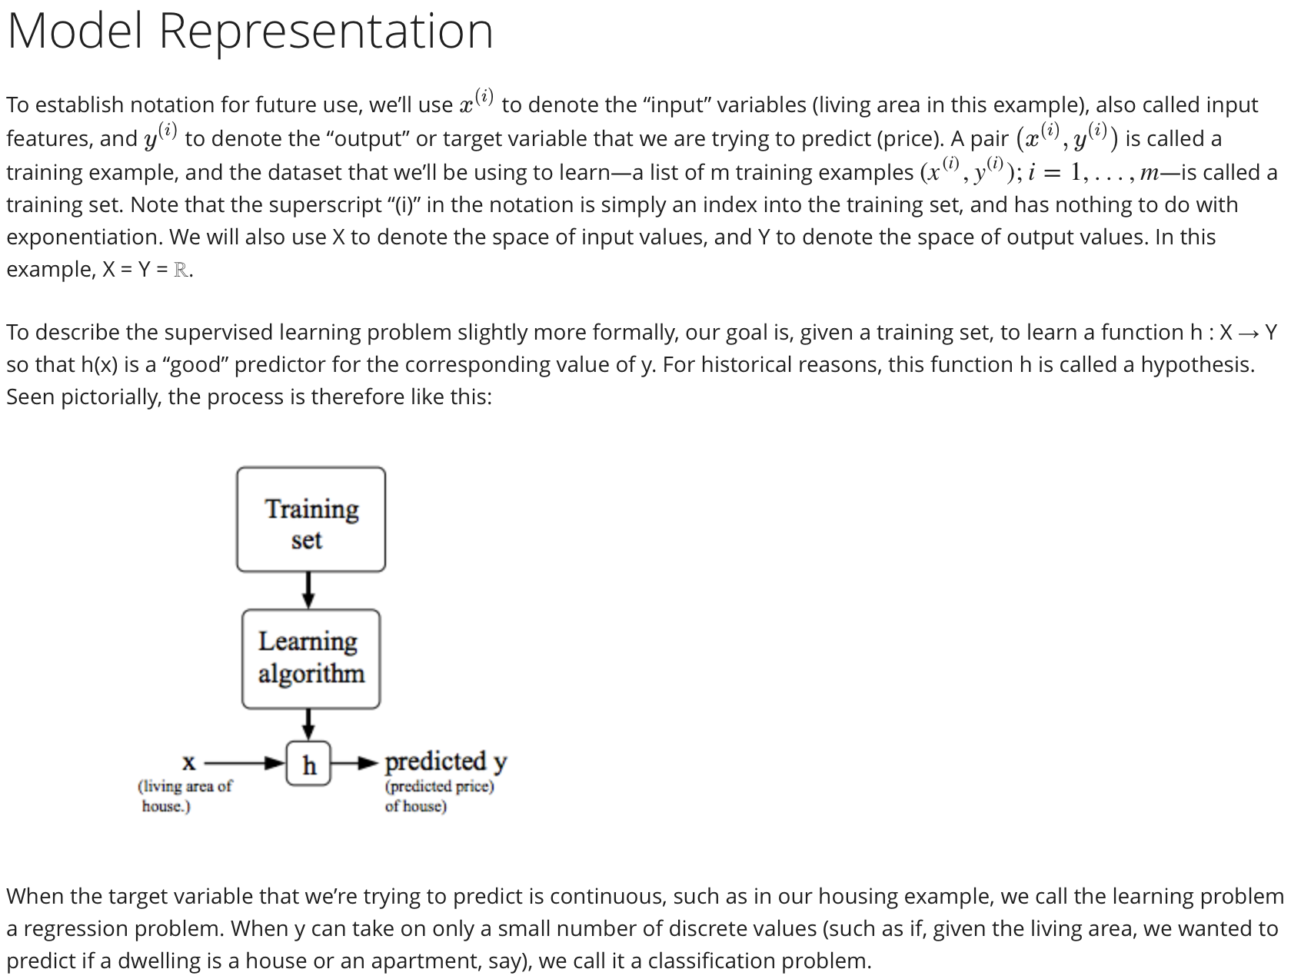

Cost Function: How to fit the best possible straight line to our data

hø(x) = ø0 + ø1x

thetas here are the parameters

How to choose thetas?

Choose thetas so that h(x) is close to y for our training examples (x,y)

We want to minimize this cost function of thetas J(ø0,ø1)

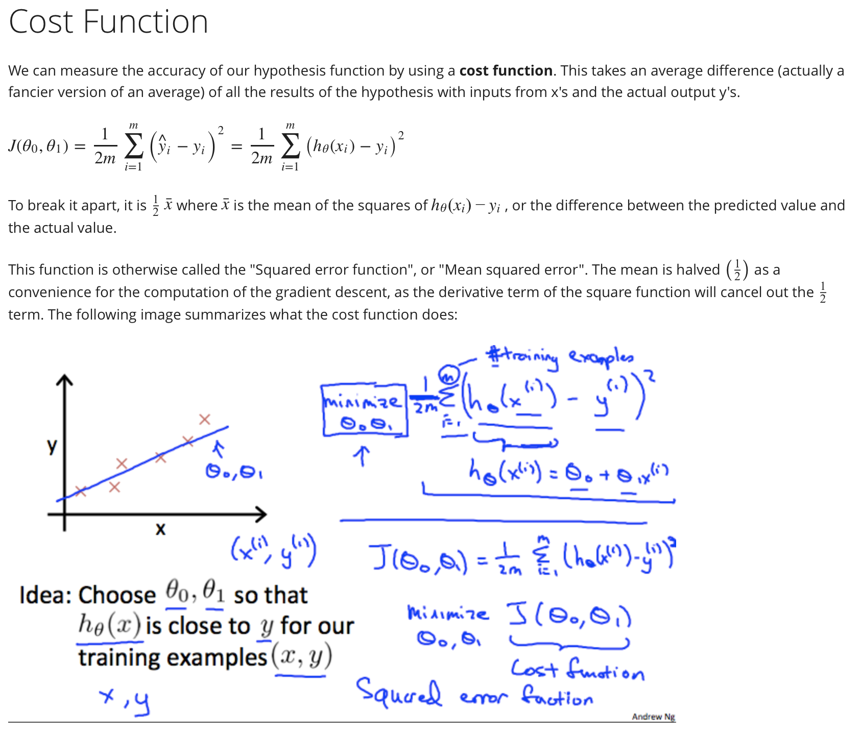

Cost Function Intuition 1

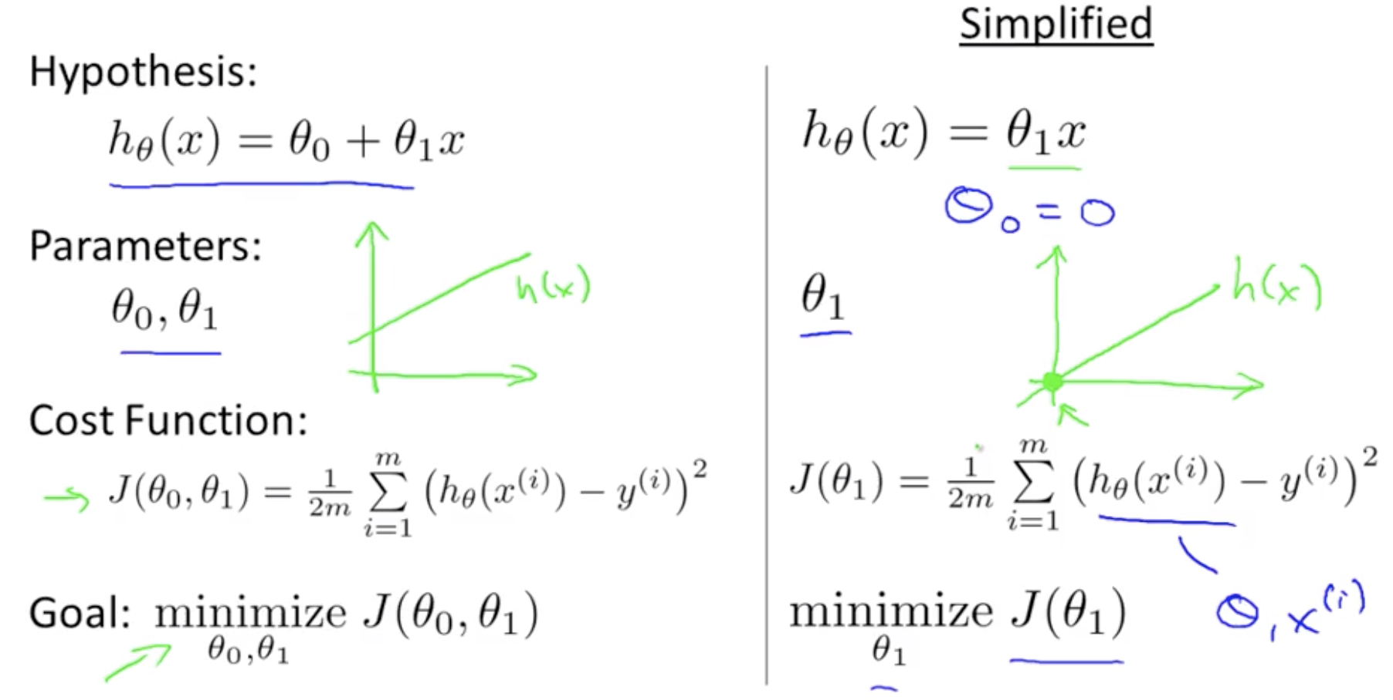

First let’s try to understand the cost function and hypothesis function better.

The cost function will changes ‘cost’ as we change the values of theta. We can then plot the cost function. Our optimization object is to choose the value of theta that minimizes the cost function J.

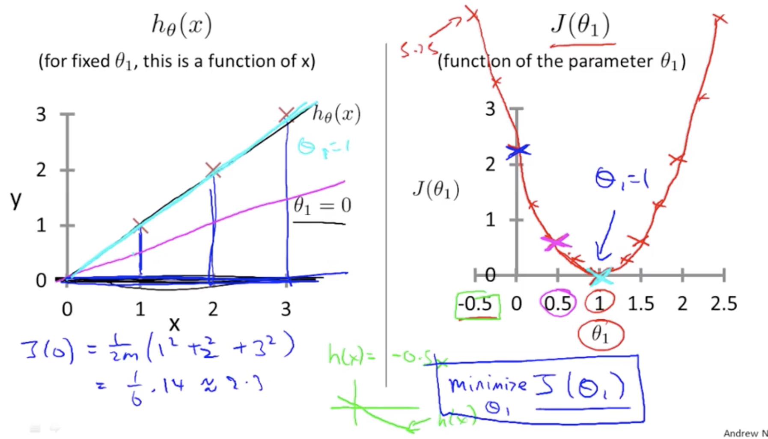

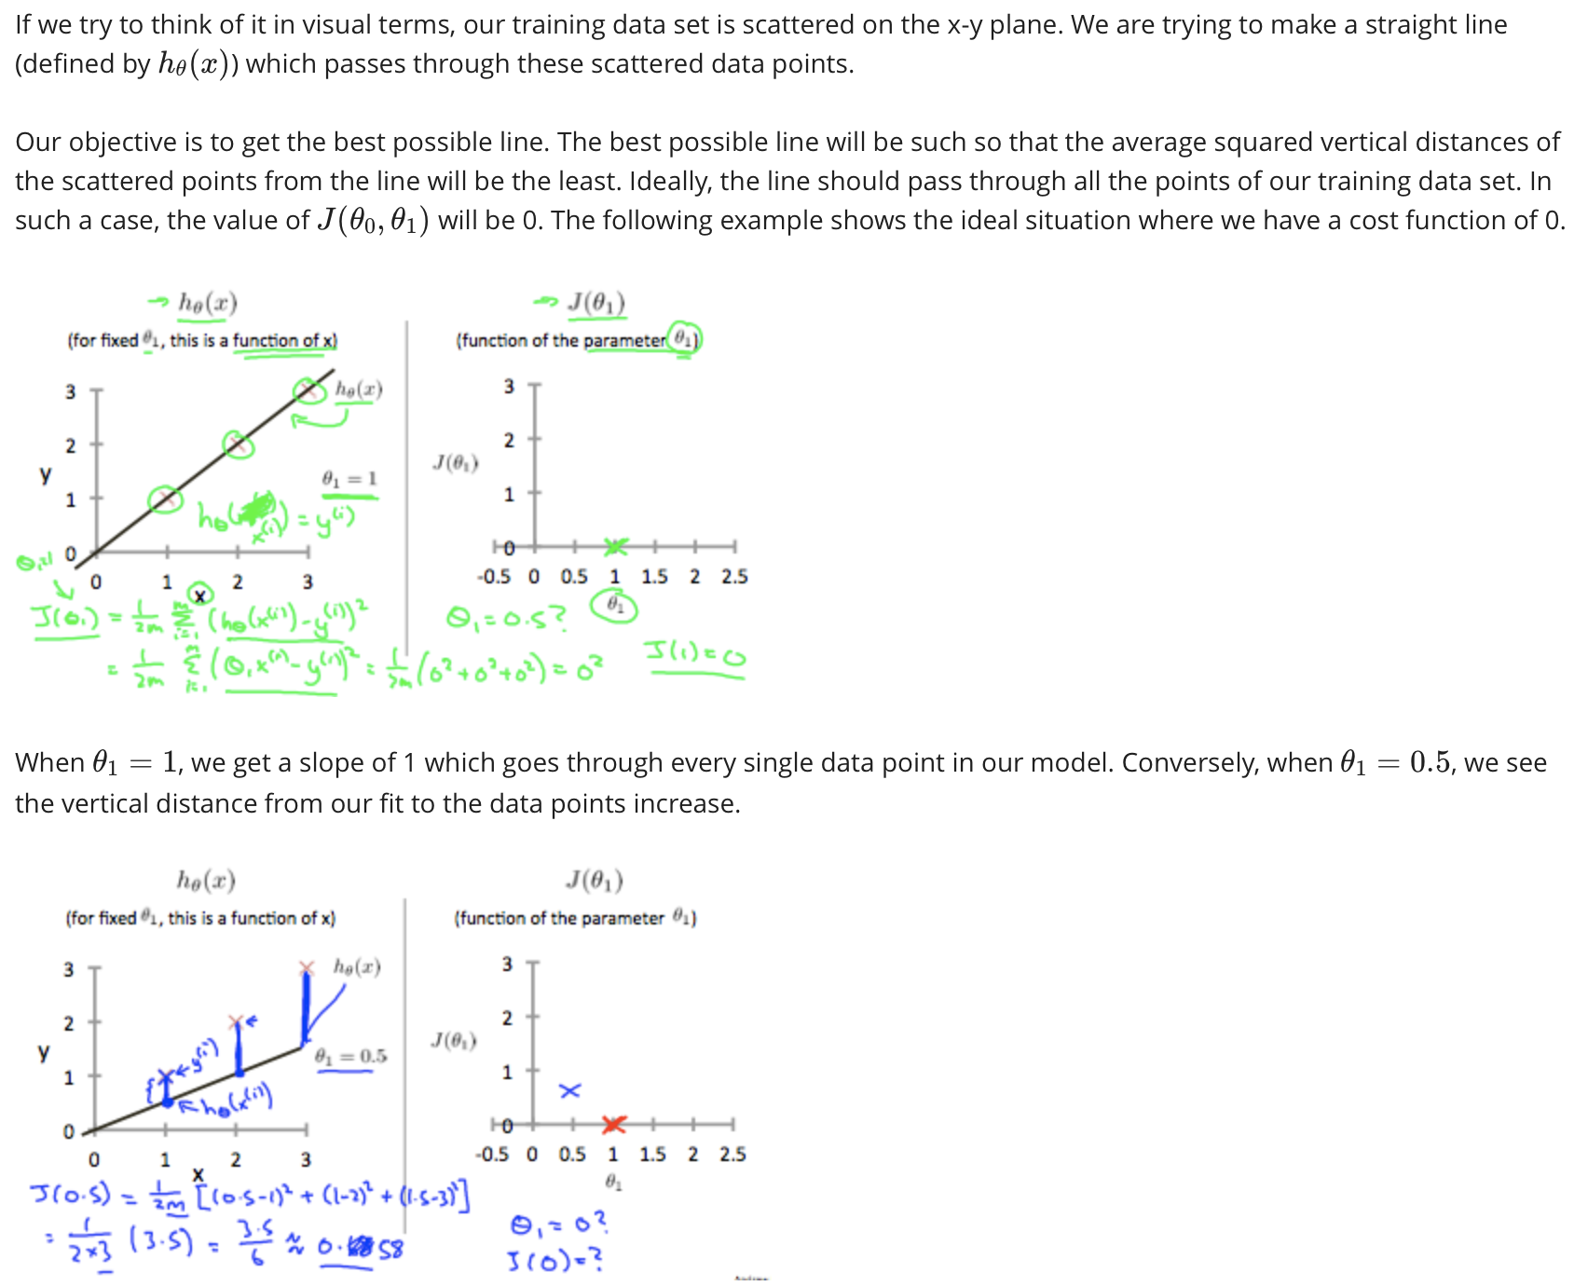

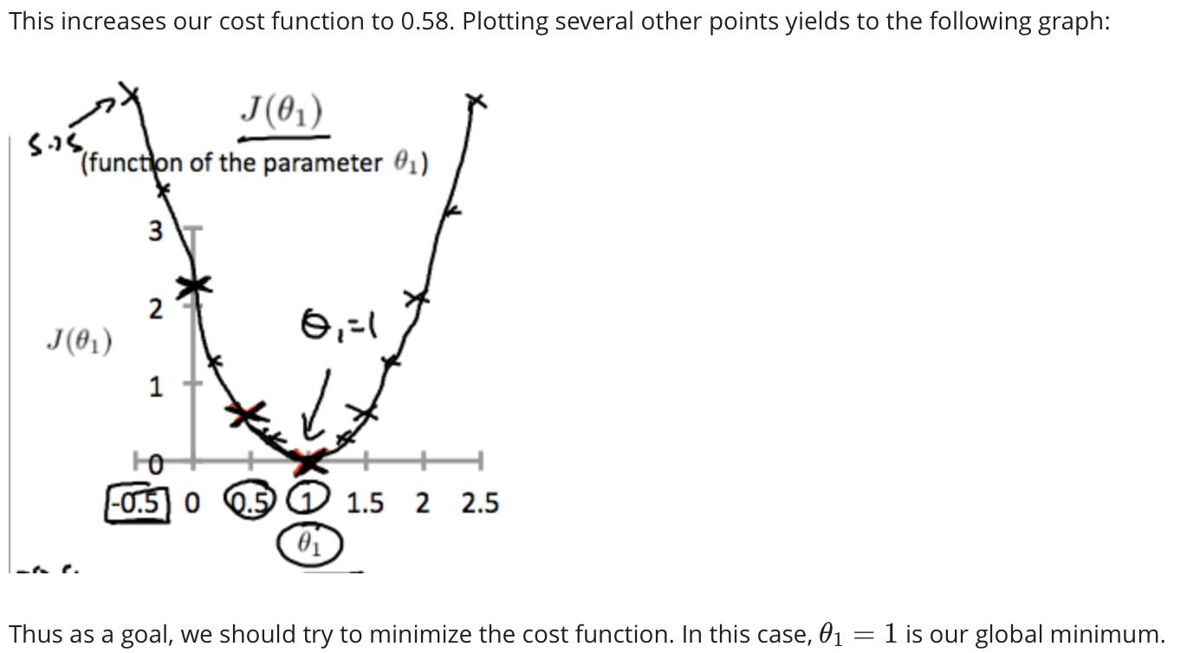

Cost Function Intuition 2

Same as last time, we want to understand hypothesis function h and minimize cost function J with theta 0 and theta 1:

2D Contour plot of Cost Function J for theta 0 and theta 1:

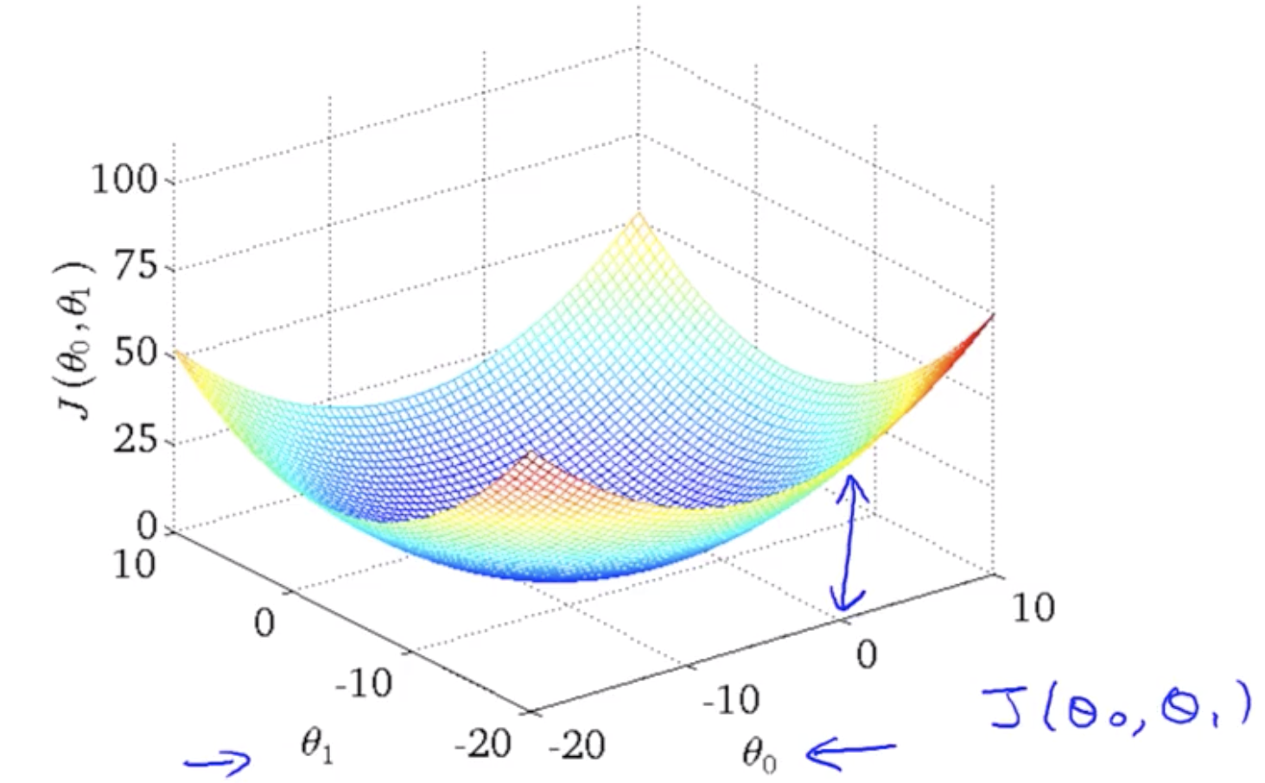

We want to create an algorithm to quickly find the minimum as quickly as possible to minimize the cost function of theta 0 and theta 1.

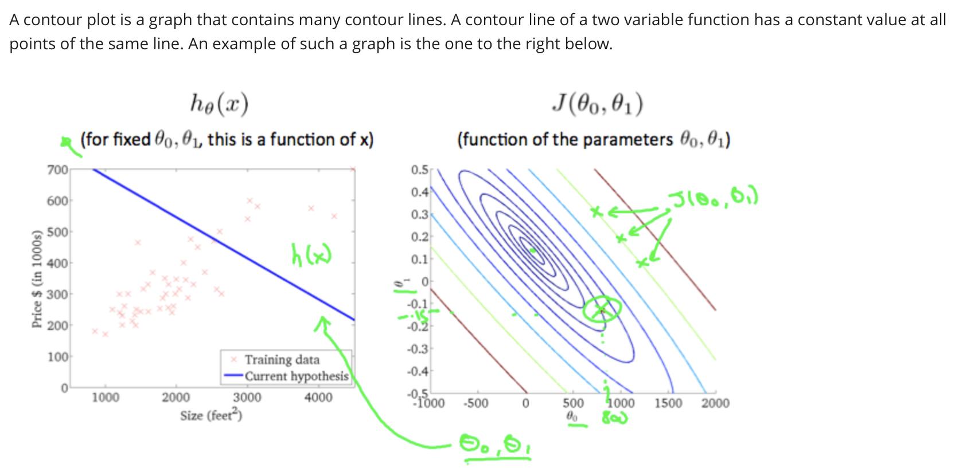

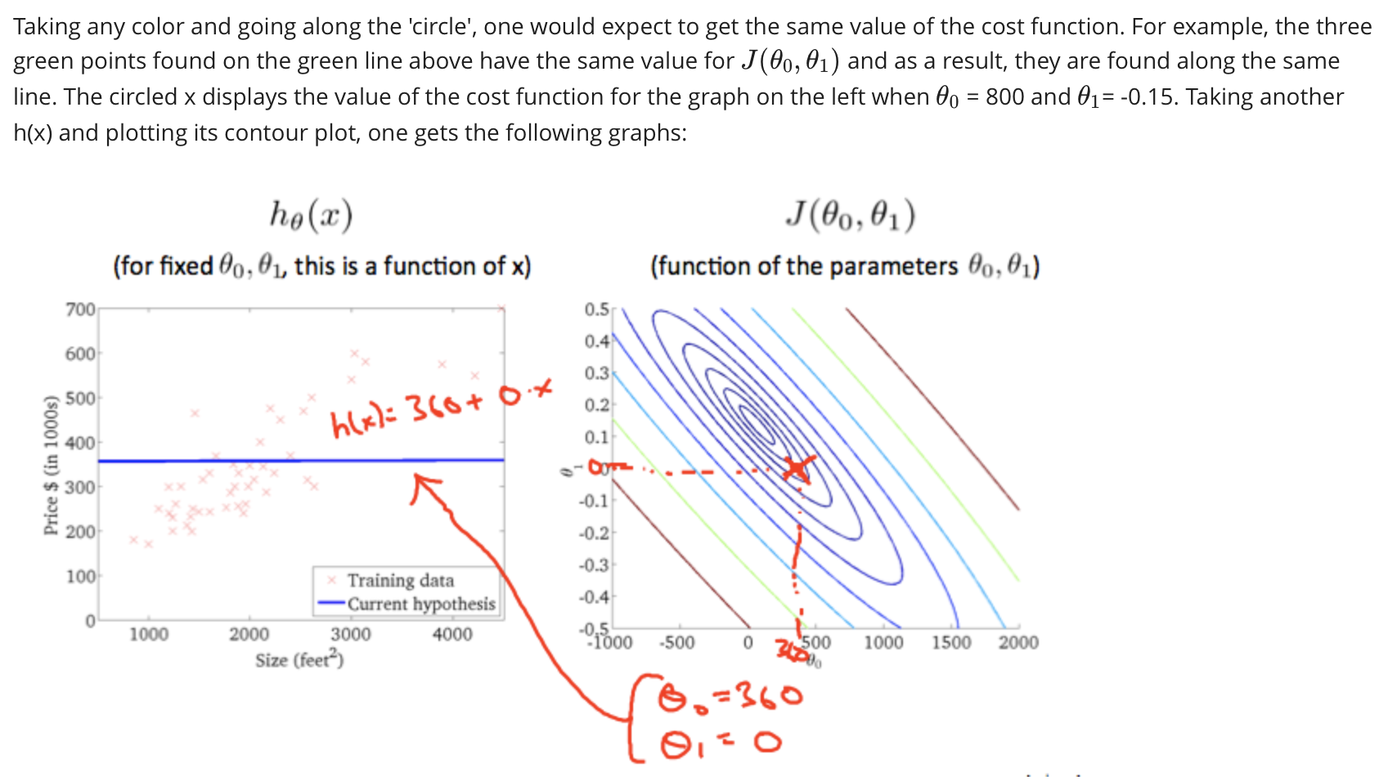

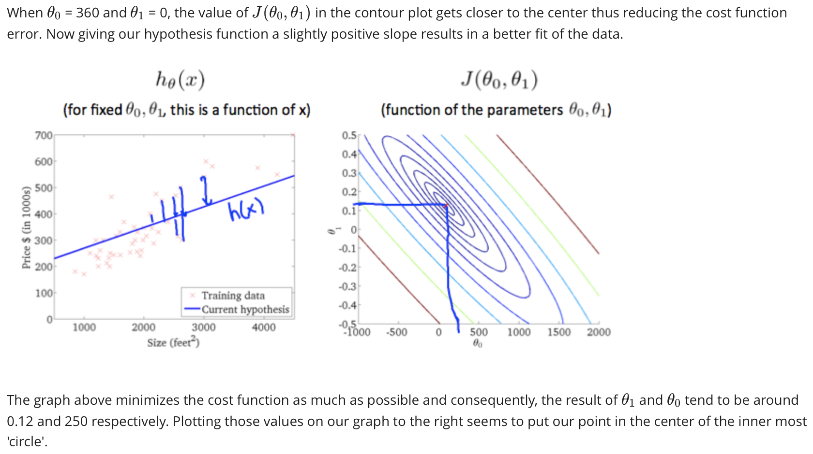

Gradient Descent

We want to create an algorithm to minimize J

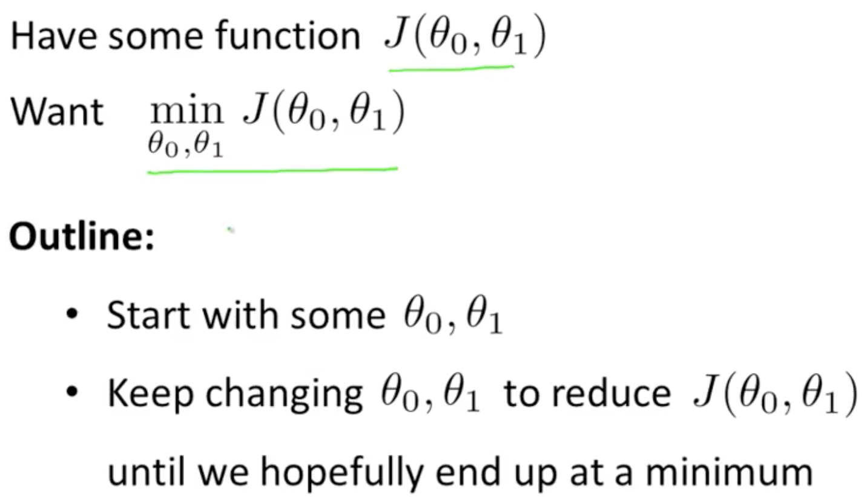

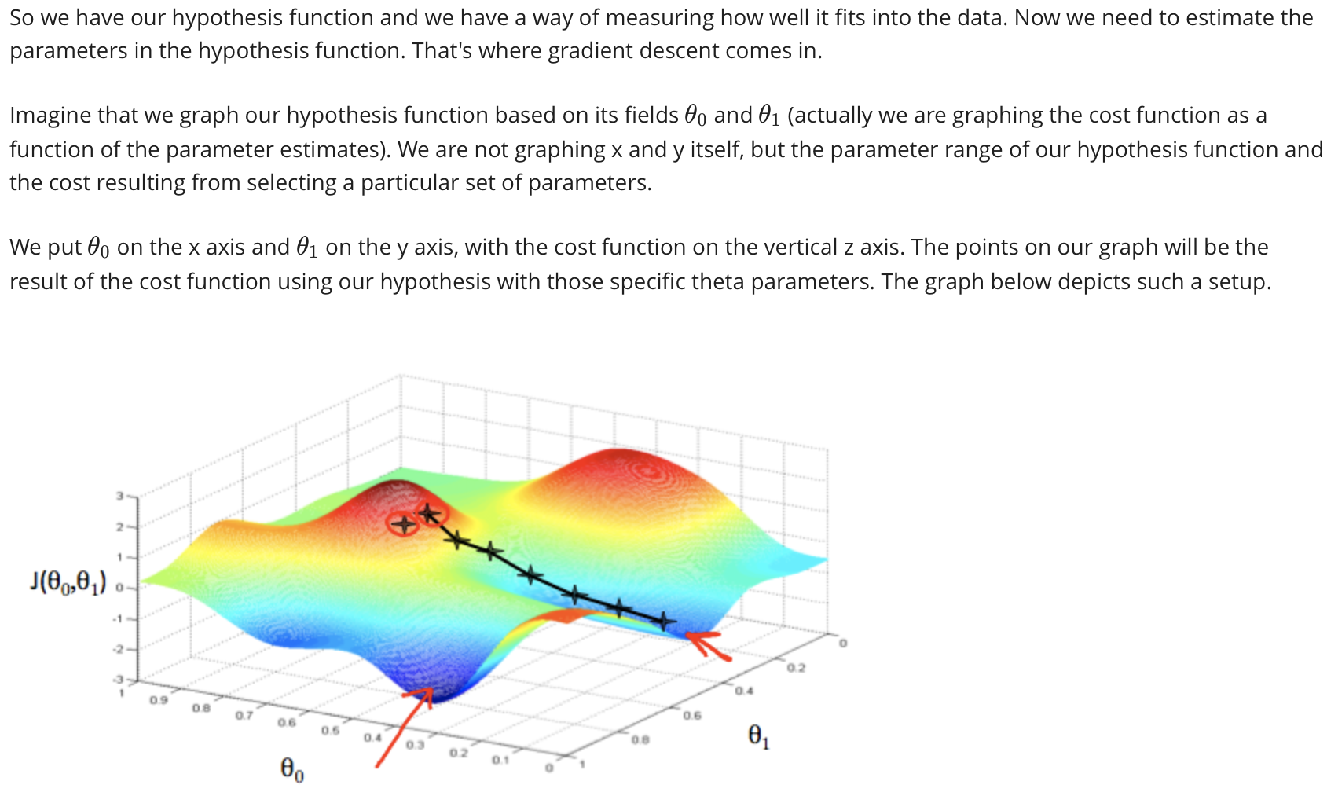

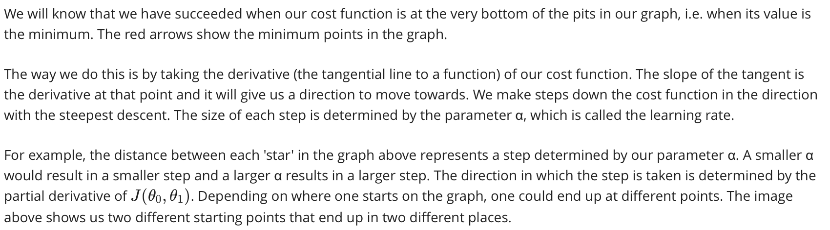

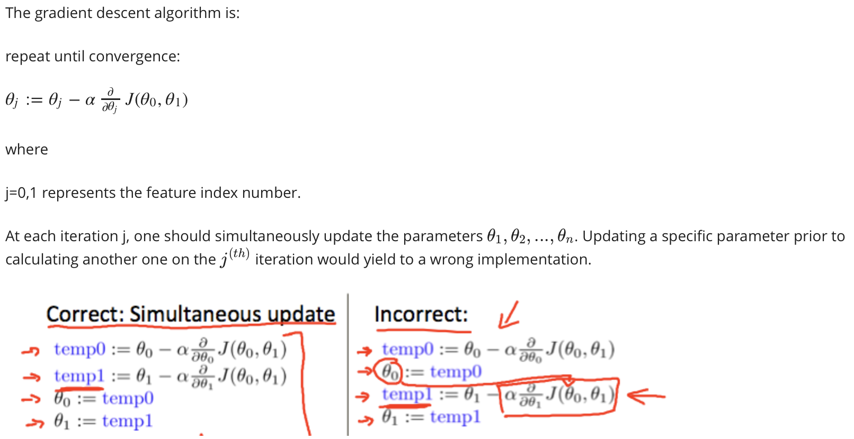

Gradient Descent Intuition

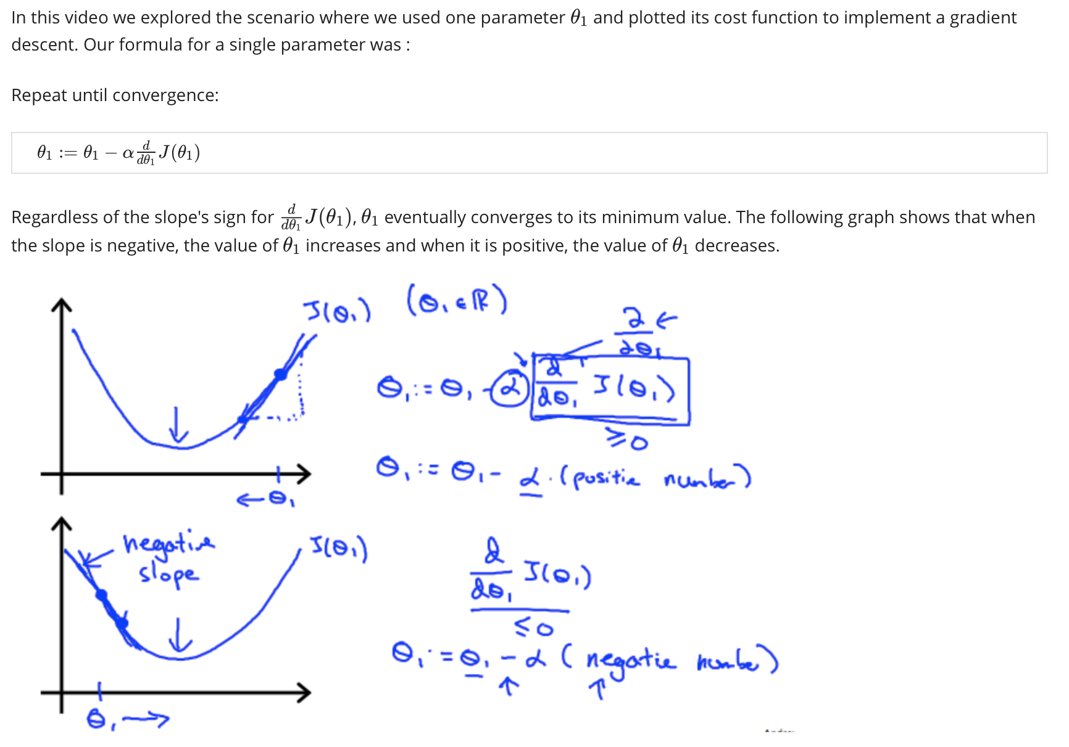

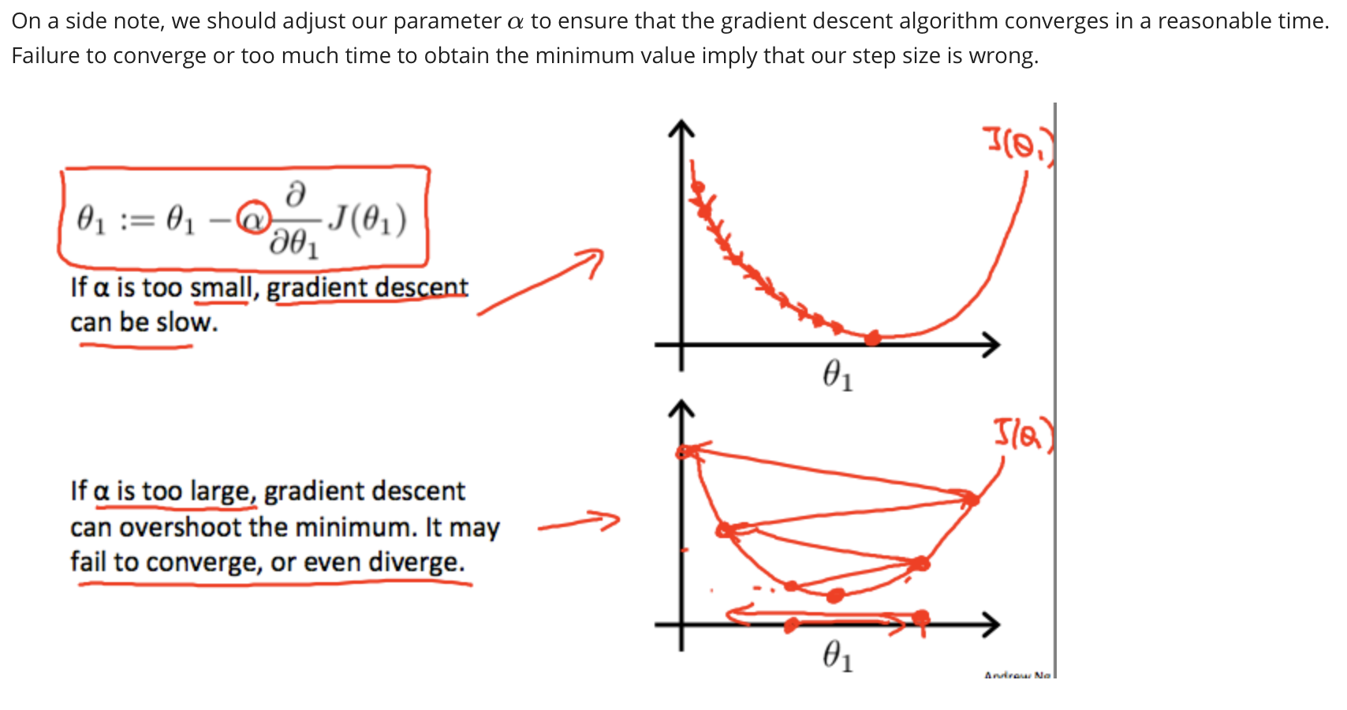

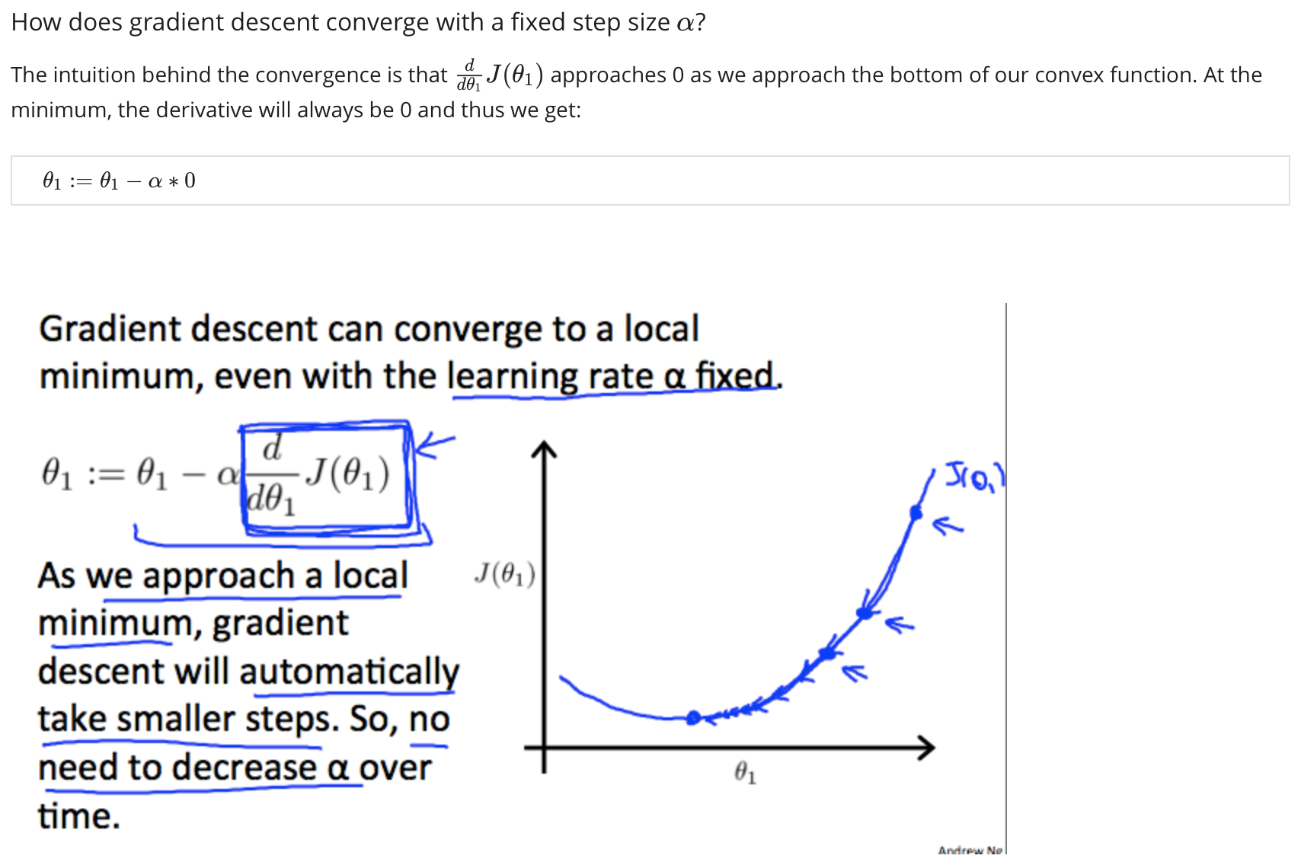

Gradient Descent for Linear Regression

We are going to apply the gradient descent algorithm to minimize our squared error cost function.

We first need to work out what the partial derivative is:

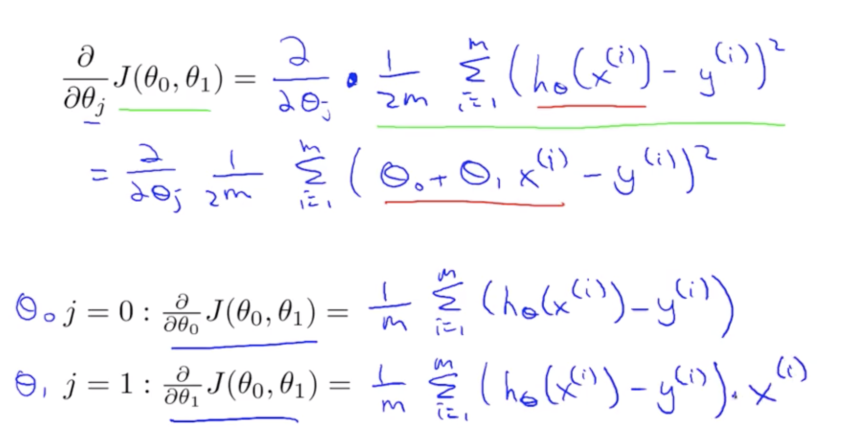

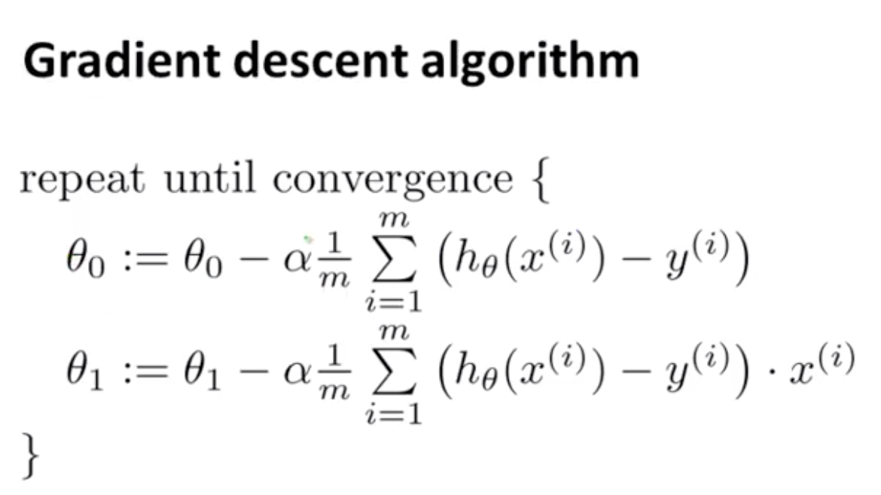

Remember to update theta 0 and theta 1 simultaneously.

Also remember gradient descent can be susceptible to moving to a local minimum instead of a global minimum.

This algorithm is also called ‘Batch’ Gradient descent: In each step of gradient descent we use **all** the training examples.

There are also non batch versions that look at smaller sets of the training examples.

